INTERNSHIP REPORT
On
EDUCATION MANAGEMENT SYSTEM IN SERVICENOW
An internship report submitted in partial fulfilment of the requirements for the
Award of a Degree of
BACHELOR OF TECHNOLOGY
in
INFORMATION TECHNOLOGY
[2022-2026]
Submitted by
NAGAVARAPU SARASWATHI DEVI
Regd. No.: 22A51A12H3
Under Supervision of
Ms.B.Reshma
(Mentor)
Service Now, SMARTBRIDGE.
(Duration:2nd May 2025 to 28 June 2025)

DEPARTMENT OF COMPUTER SCIENCE AND ENGINEERING
ADITYA INSTITUTE OF TECHNOLOGY AND MANAGEMENT
(An Autonomous Institution)
Approved by AICTE, Permanently Affiliated JNTUGV, Vizianagaram, Accredited
By NBA (Tier – 1) and NAAC with Grade ‘A+’
K.KOTTURU, TEKKALI-532201, Srikakulam (Dist.), Andhra Pradesh, India
2025-2026

DEPARTMENT OF INFORMATION TECHNOLOGY
ADITYA INSTITUTE OF TECHNOLOGY AND MANAGEMENT
(An Autonomous Institution)
TEKKALI



This is to certify that the “Internship Report” submitted by NAGAVARAPU SARASWATHI DEVI (Regd.No:22A51A12H3) is work done by her and submitted during the 2025- 2026 academic year, in partial fulfilment of the requirements for the award of the degree of BACHELOR OF TECHNOLOGY in INFORMATION TECHNOLOGY, at Service now, SMARTBRIDGE.

Department Internship Coordinator  Sri. P. Anjaneyulu, M.Tech.,  Assistant Professor, CSE | Dr. Y. Ramesh, M.Tech., Ph.D.  Head of the Department  Department of IT
College Internship Coordinator
Dr. B. Rajesh, Ph.D.
ACKNOWLEDGEMENT

First, I would like to thank MS.B.Reshma, the Mentor at ServiceNow, SMARTBRIDGE for allowing me to do an internship within the organization.

I also would like all the people who worked along with me at Servicenow, SMARTBRIDGE. with their patience and openness, they created an enjoyable working environment.

I would like to thank Sri. P. Anjaneyulu, Internship Coordinator of the CSE department and Dr. B. Rajesh, College Internship Coordinator for their support and advice to get and complete an internship in above said organization.

It is indeed with a great sense of pleasure and immense sense of gratitude that I acknowledge the help of these individuals.

I would like to thank my Head of the Department Dr. Y. Ramesh for his constructive criticism throughout my internship.

I am highly indebted to Principal Dr. A.S.Srinivasa Rao and Director Prof. V.V. Nageswara Rao for the facilities provided to accomplish this internship.

I am extremely grateful to my department staff members and friends who helped me in successful completion of this internship.

N. SARASWATHI DEVI
(22A51A12H3)

ABSTRACT

Project Title: Educational Management System in ServiceNow

This project is designed to make student admission and record management easier and faster for educational institutions. Using the ServiceNow platform, we created a digital system that replaces manual work with an automated process.

The system includes a self-service portal where students can submit admission requests. It uses custom tables and automated workflows to handle and store all student data safely. The main goal is to remove manual errors, reduce the time needed for admissions, and lower the workload for teachers and administrators.

Important tools like Client Scripts, Flow Designer, and Number Maintenance are used to validate data, create and update records, and assign unique student numbers. The system also sends automatic notifications and helps generate quick reports.

All components are packed using Update Sets, making deployment easy. This project shows how ServiceNow can simplify and improve education management through automation, accuracy, and transparency.

Keywords: ServiceNow, Education Automation, Admission Management, Student Records, Workflow Optimization

Organization Information

SMARTBRIDGE is a leading technology learning and innovation platform that collaborates with global enterprises, educational institutions, and students to offer hands-on industry experience. Through academic partnerships and corporate training programs, SMARTBRIDGE enables learners to work on real-world projects in emerging technologies such as ServiceNow, AI/ML, Cloud, IoT, and Cybersecurity. For this project, the focus was on ServiceNow, a leading cloud-based workflow automation platform developed by ServiceNow Inc., headquartered in Santa Clara, California. ServiceNow provides enterprise solutions that streamline operations, enhance service delivery, and automate IT, HR, and business processes. By integrating academic learning with industry-standard platforms like ServiceNow, SMARTBRIDGE ensures practical skill development and prepares students to meet the evolving demands of the modern digital workplace.

Programmes and Opportunities

SMARTBRIDGE provides students with opportunities to engage in industry-focused projects, virtual internships, and skill-development programs. By leveraging ServiceNow, this program allowed us to explore key areas of workflow automation, IT service management, and application development. Participants gained exposure to ServiceNow Administration, Flow Designer, Catalogue Management, and Scripting for process automation. The internship emphasized digital transformation in network operations, and in this case, the project focused on Automated Network Request Management. This hands-on experience enhanced technical proficiency, teamwork, and problem-solving skills aligned with real-world enterprise practices.

Methodology

Our project, “Educational Management System in ServiceNow,” aimed to build an automated system that makes all educational management tasks digital and efficient.
We used ServiceNow to design and implement the process in these steps:
- Created custom tables to store student, admission, and progress data.
- Designed an Admission Process Flow using Flow Designer to automate actions.
- Used Client Scripts to check and control data entered in specific fields.
- Set up Number Maintenance to automatically generate unique Admin IDs.
- Packaged all updates using Update Sets for easy deployment.
We also added Access Control Lists (ACLs) and role-based permissions to protect sensitive information and allow only authorized users to access data. By following standard industry practices, the project achieved better automation, higher accuracy, and improved efficiency in managing student data.

Key parts of the report

The project report starts with an introduction that explains the main goals, scope, and the importance of automating educational management.
The methodology section describes how ServiceNow was configured using custom tables like the Admission Table and Student Progress Table, along with Client Scripts and Flow Designer workflows.
The implementation part explains how the database was built, how the admission process was automated, and how notifications and progress tracking were added.
The results show that the system made admission processing faster, improved data accuracy, and provided better transparency for teachers and staff.
Finally, the conclusion summarizes the achievements, key learnings, and possible future improvements.

Benefits to the company / institution through your report

The report benefits SMARTBRIDGE by demonstrating how ServiceNow can automate educational management, providing a practical example of workflow optimization in a non-IT sector. It highlights efficiency improvements through automated admissions, progress tracking, and notifications, reducing manual effort and errors. For SMARTBRIDGE, the project reinforces its focus on industry-relevant, hands-on learning. For educational institutions, it showcases improved process transparency, faster admission and tracking, and the ability for teachers to easily monitor student performance.
Learning Objectives/Internship Objectives

- Gain hands-on experience in using ServiceNow to automate educational processes and improve efficiency.
- Learn how to create and configure Service Catalog items and Client Scripts to capture and validate user inputs.
- Develop skills in database table design, including creating custom tables like Admission Table and Student Progress Table, adding fields, setting relationships, and using Number Maintenance for automatic IDs.
- Understand how to use Flow Designer to automate workflows such as creating records, sending notifications, requesting approvals, and updating data.
- Learn to configure email notifications and task assignments to improve communication and visibility.
- Gain knowledge of role-based access control, validation rules, and data integrity to maintain system security.
- Experience the complete project lifecycle — from requirement gathering to design, development, and deployment using Update Sets.
- Strengthen professional skills like problem-solving, teamwork, and communication.
- Deliver a scalable, automated solution that simplifies student admissions, reduces manual work, and increases accuracy.

INDEX

S.No | CONTENT | Page No
1. | Objectives &Project Overview | 10 - 11
2. | Service Catalogue Creation | 12 - 18
3. | Creation of Table | 19 - 24
4. | Request Approvals Created | 25 - 26
5. | Overview of Flows, Actions in Flow Designer | 27 - 28
6. | Creation & Implementation of Flows, Actions in Flow Designer | 29 - 28
7. | Final Testing in End User Portal & Instance | 36
8. | Advantages | 37 - 38
9. | Conclusion | 39
10. | Certificate | 40

Figure No | Description | Page No
Fig 1.1 | Navigation to Service Catalogue | 12
Fig 1.2 | Create a catalogue item | 13
Fig 1.3 | Configure Variables | 14
Fig 1.4 | Variables Type Configuration | 14
Fig 1.5 | Create Variable set | 15
Fig 1.6 | Configure Variable set -Requester Information | 15
Fig 1.7 | Add Variables to the Variables Variable set | 16
Fig 1.8 | Add all the Variables | 17
Fig 1.9 | Create a catalogue client script | 18
Fig 1.9(a) | Configure the Script Fields | 18
Fig 1.9(b) | Catalogue UI Policy Configuration | 19
Fig 2.1 | Create a table for network database | 20
Fig 2.2 | Add Custom Fields | 22
Fig 2.3 | Auto populate Database Number | 22
Fig 2.4 | Create a Network Task Table | 23
Fig 2.5 | Verify Inherited Fields | 24
Fig 2.6 | Configure the auto numbering | 25
Fig 2.7 | Create a Flow | 27
Fig 2.8 | Conf Configuring the Trigger ignoring the Trigger | 28
Fig 2.9 | Adding Actions | 29
Fig 3.1 | Create Record | 29
Fig 3.2 | Send Email | 30
Fig 3.3 | Ask for Approvals | 31
Fig 3.4 | Flow Logic | 31
Fig 3.5 | Update Record | 32
Fig 3.6(a) | Create Network Task Table Record | 33
Fig 3.6(b) | Request created for send email | 33
Fig 3.6(c) | Ask for Approval | 34
Fig 3.6(d) | Send email(approved) | 35
Fig 3.6(e) | Flow Logic (rejected) | 35
Fig 3.7 | Flow of Network Request | 36
Week | Date | Day | Topic / Module Discussed
Week 1 – Introduction & Basics | 12-05-2025 | Monday | Orientation & Introduction to SMARTBRIDGE, Project Overview
 | 13-05-2025 | Tuesday | Understanding ServiceNow Platform & ITSM Concepts
 | 14-05-2025 | Wednesday | Service Catalogue Overview and Planning
 | 15-05-2025 | Thursday | Creation of Service Catalogue
 | 16-05-2025 | Friday | Variables Configuration & Variable Types
 | 17-05-2025 | Saturday | Variable Set Configuration & Catalogue UI Policy Configuration
Week 2 – Table Design & Data Configuration | 19-05-2025 | Monday | Overview of Tables and Schema in ServiceNow
 | 20-05-2025 | Tuesday | Creation of Network Request Table
 | 21-05-2025 | Wednesday | Field Creation and Property Definition
 | 22-05-2025 | Thursday | Adding Fields to Form
 | 23-05-2025 | Friday | Table Relationships & Related Lists
 | 24-05-2025 | Saturday | Adding Related List to Network Request Table
Week 3 – Request Approvals | 26-05-2025 | Monday | Introduction to Request Approvals
 | 27-05-2025 | Tuesday | Creation of Approval Table / Related List
 | 28-05-2025 | Wednesday | Integrating Approvals with Network Request Table
 | 29-05-2025 | Thursday | Approval Routing & Notifications Setup
 | 30-05-2025 | Friday | Testing Approval Workflows
 | 31-05-2025 | Saturday | Debugging and Optimizing Approvals
Week 4 – Flow Designer Basics | 02-06-2025 | Monday | Overview of Flow Designer and its Components
 | 03-06-2025 | Tuesday | Navigating Flow Designer
 | 04-06-2025 | Wednesday | Creating a Flow in Flow Designer
 | 05-06-2025 | Thursday | Adding and Configuring Actions
 | 06-06-2025 | Friday | Testing and Debugging Flows
 | 07-06-2025 | Saturday | Best Practices for Flow Designer
Week 5 – Flow Implementation (Part 1) | 09-06-2025 | Monday | Creation & Implementation of Flows (Intro)
 | 10-06-2025 | Tuesday | Configuring Flow Triggers
 | 11-06-2025 | Wednesday | Configuring Flow Actions
 | 12-06-2025 | Thursday | Flow Chart Design for Request Lifecycle
 | 13-06-2025 | Friday | Conditional Logic & Approval Automation
 | 14-06-2025 | Saturday | Notifications & SLA Integration
Week 6 – Flow Implementation (Part 2) | 16-06-2025 | Monday | Enhancing Flows with Custom Scripts
 | 17-06-2025 | Tuesday | Task Creation & Assignment Automation
 | 18-06-2025 | Wednesday | Integration with Network Task Table
 | 19-06-2025 | Thursday | Testing & Debugging Enhanced Flows
 | 20-06-2025 | Friday | Review and Documentation of Flows
 | 21-06-2025 | Saturday | Mid-Project Demo & Feedback Session
Week 7 – End User Portal & Testing | 23-06-2025 | Monday | Introduction Service Portal Configuration
 | 24-06-2025 | Tuesday | Adding Network Request Catalogue to Service Portal
 | 25-06-2025 | Wednesday | Testing in Service Portal (End User)
 | 26-06-2025 | Thursday | Testing with Custom Tables
 | 27-06-2025 | Friday | Email Notifications Testing
 | 28-06-2025 | Saturday | UI Enhancements and Final Bug Fixes
Week 8 – Final Testing  & Project Documentation | 30-06-2025 | Monday | Final Testing in End User Portal & Instance
 | 01-07-2025 | Tuesday | Documentation of Workflows and Approvals
 | 02-07-2025 | Wednesday | Project Report Writing
 | 03-07-2025 | Thursday | Creating Final Demo Presentation
 | 04-07-2025 | Friday | Internal Review & Submission
 | 05-07-2025 | Saturday | Final Presentation & Evaluation
Week 9 – Project Completion & Presentation | 07-07-2025 | Monday | Preparing PPT & Demonstration
 | 08-07-2025 | Tuesday | Dry Run of Presentation
 | 09-07-2025 | Wednesday | Final Project Execution & Submission
 | 10-07-2025 | Thursday | Feedback & Evaluation
 | 11-07-2025 | Friday | Internship Closure & Reflection

Educational Management System in ServiceNow
OBJECTIVES
The main objective of this project is to automate and simplify educational service management using the ServiceNow platform.
It provides a self-service portal for student admissions, uses automated workflows for approvals, notifications, and record creation, and supports real-time tracking of student progress.
The project helps reduce manual work, minimize data errors, and improve communication between students, teachers, and administrators — resulting in faster and more efficient operations.

Key Goals
- Simplify Request Submission:
Create a user-friendly self-service portal that allows students to easily submit admission requests online.
- Automate Approvals and Workflows:
Use ServiceNow Flow Designer to automate approvals, notifications, and record creation, reducing manual steps and delays.
- Enhance Data Management
Build custom tables such as the Admission Table and Student Progress Table with auto-generated Admin IDs for accurate student record tracking.
- Ensure Real-Time Visibility
Provide dashboards and lists for administrators and teachers to instantly monitor admission status and student performance.
- Reduce Errors and Improve Efficiency
Use Client Scripts and automated processes to reduce human error and save time in data handling.
- Deliver a Scalable and Transparent Solution
Develop a secure, reliable, and easy-to-use system that ensures transparency and smooth workflow management across the institution.

Project Overview
The Educational Management System in ServiceNow offers a complete digital solution for managing administrative activities such as student admissions and progress tracking.
Through a self-service portal, students can easily submit admission requests, which are automatically validated using Client Scripts and processed by Flow Designer.
The system automates key actions such as approvals, notifications, and record creation in custom tables like the Admission Table and Student Progress Table.
Features like real-time updates and auto-generated Admin IDs (via Number Maintenance) improve transparency and speed.
This automated setup reduces manual work, prevents errors, and supports a clear and efficient workflow for administrators and teachers.

Why This Project?
Manual handling of educational administration is often slow, error-prone, and difficult to manage. Data entry mistakes and delays in admissions create inefficiencies, while tracking student progress manually lacks transparency.
This project uses ServiceNow automation tools — including Service Catalogs, Flow Designer, Custom Tables, and Client Scripts — to simplify and automate the entire process.
The system ensures consistent data handling, provides real-time tracking, and enables faster service delivery. As a result, it improves efficiency, accuracy, and visibility for both teachers and administrators.

EDUCATIONAL ORGANISATION USING SERVICENOW
INTRODUCTION:
This project delivers an automated educational management solution using the ServiceNow platform. Through a self-service portal, users can easily submit admission requests that are automatically validated, approved, and recorded in the system. Automated workflows manage approvals, notifications, and record creation in tables such as the Admission Table and Student Progress Table. The system provides real-time updates and tracking, which greatly enhance efficiency, transparency, and accuracy in managing educational processes.
Process 1: Creation of Custom Tables (Adapted from Source 2302) To store all educational data, we created custom tables.
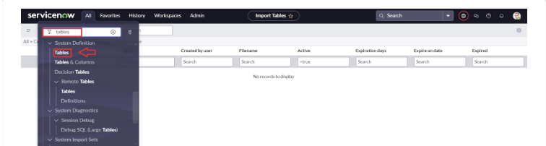
(Fig:1.1:Navigation to Tables)
Step 1: Create a New Table (e.g., Admission Table)
- Navigate to System Definition > Tables.
- Click on New.
- Fill in the table details:
  - Label: Admission Table
  - Name: u_admission_table (auto-generated)
- Click Submit.
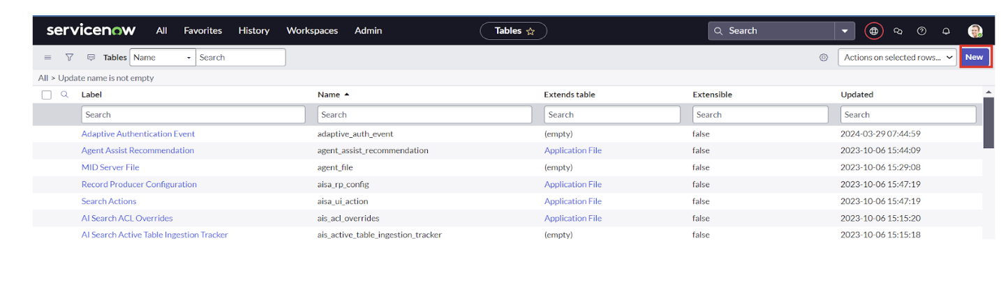
(Fig:1.2:Creating a new table)
Step 2: Add custom fields to the "Admission Table"
- Student Name (Type: String)
- Status (Type: Choice, e.g., 'Submitted', 'In Review', 'Approved', 'Rejected')
- Contact (Type: String)
- Admin ID (Type: String)
- (Other relevant admission fields)
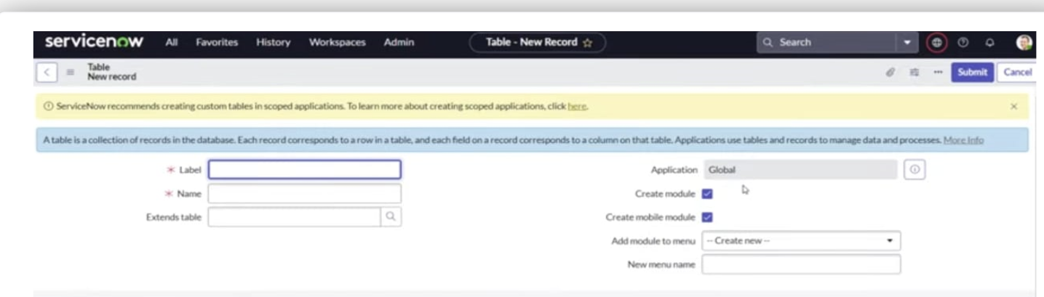
(Fig:1.3: Entering the Label)
Step 3: Create the "Student Progress Table"
- Repeat Step 1 for a new table.
  - Label: Student Progress Table
  - Name: u_student_progress_table
- Add custom fields:
  - Student (Type: Reference, points to User or Admission table)
  - Subject (Type: String)
  - Marks (Type: String)
  - Performance Details (Type: String)
Step 4: Configure Auto-Numbering for Admin ID
- Navigate to System Definition > Number Maintenance.
- Click New.
- Fill in details:
  - Table: Admission Table (u_admission_table)
  - Prefix: ADM
  - Number of Digits: 7
- This configures the "Admin Number" to be generated automatically.

Process 2: Creation of Service Catalogue & Client Scripts
(Adapted from Sources 2187, 2271) To create the user-facing admission form.
Step 1: Create New Catalogue Item
- Navigate to Service Catalogue > Maintain Items.
- Click on New.
- Fill in the details:
  - Name: Student Admission Request
  - Catalogue: Service Catalogue
  - Category: (e.g., 'Admissions')
Step 2: Configure Variables
- Add variables (questions) to the form, such as 'Full Name', 'Email', 'Contact Number', 'Previous Education'.
Step 3: Create a Catalogue Client Script This script is used to validate data in real-time.
- Navigate to Service Catalogue > Catalogue Client Scripts.
- Click New.
- Fill in details:
  - Name: Validate Admission Form
  - Applies to: A Catalogue Item
  - Catalogue Item: Student Admission Request
  - Type: onChange (or onSubmit)
- Write a script to ensure, for example, that the 'Contact Number' is in a valid format. This improves data accuracy.

Process 3: Creation & Implementation of Flow in Flow Designer
(Adapted from Source 2452) This flow automates the Admission Process.
Step 1: Creating the Flow
- Navigate to Flow Designer.
- Click New > Flow.
- Enter:
  - Flow Name: Student Admission Process
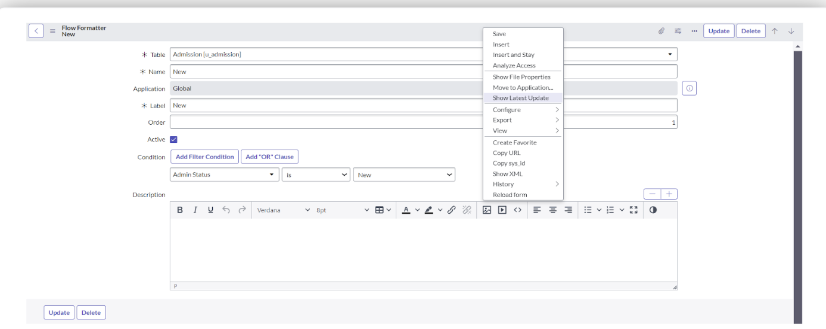
(Fig:1.4:Creating a Flow)
Step 2: Configuring the Trigger
- Click Add a trigger.
- Select Service Catalogue. This means the flow will start when the admission form is submitted.
Step 3: Adding Actions
- Get Catalogue Variables: Get all the data (Name, Email, etc.) from the submitted form.
- Create Record:
  - Action: Create a new record in the Admission Table (u_admission_table).
  - Fields: Map the variables from the form to the fields in the table (e.g., Form's 'Full Name' variable goes into the 'Student Name' field).
- Ask for Approvals:
  - Action: Send an approval request (e.g., to the Admissions Office group).
  - Record: Use the 'Admission Table' record created in the previous step.
- Flow Logic (If Condition):
  - Condition: Check if the approval state is 'Approved'.
- Actions (If Approved):
  - Update Record: Update the 'Admission Table' record's 'Status' field to 'Approved'.
  - Create Record: (Optional) Create a basic record in the Student Progress Table for the new student.
  - Send Email: Send an email to the student welcoming them.
- Actions (If Rejected):
  - Flow Logic (Else):
  - Update Record: Update the 'Admission Table' record's 'Status' field to 'Rejected'.
  - Send Email: Send an email to the student notifying them of the rejection.

ADVANTAGES
The Educational Management System successfully automated admission and tracking processes.
- Automation of Tasks: Replaces manual work with automated workflows, saving time and reducing human effort.
- Data Accuracy: Ensures reliable and error-free data through Client Scripts and validation rules.
- Real-Time Tracking: Provides instant updates on admissions and student progress for better decision-making.
- Improved Efficiency: Speeds up the admission process and daily administrative operations.
- Enhanced Transparency: Allows teachers and administrators to easily access and monitor student information.
- Secure Data Management: Uses role-based access and permissions to protect sensitive student records.
- Scalable Solution: The system can be easily extended or modified for different educational needs and future enhancements.

CONCLUSION
The Automated Educational Management System in ServiceNow successfully streamlines student admission and academic tracking by using automation, centralized data management, and real-time monitoring. By minimizing manual work, improving data accuracy, and increasing workflow efficiency, the project delivers faster processing, greater transparency, and higher overall productivity for educational institutions.
Key achievements of this project include:
- Successful Automation: Fully automated the admission and student progress tracking process using ServiceNow workflows.

- Centralized Data System: Implemented custom tables for storing and managing all student data in one secure place.

- Improved Efficiency: Reduced manual effort and processing time through automated approvals and notifications.

- Enhanced Transparency: Enabled real-time tracking and visibility for teachers, administrators, and students.

- Secure and Scalable Solution: Applied role-based access and update sets, ensuring data protection and easy future upgrades.

This automated ServiceNow solution helps educational institutions speed up and simplify their administrative tasks. It reduces manual work, increases efficiency, and ensures faster processing with better transparency, providing a smooth and effective experience for students, teachers, and administrators.

